Requirement Analysis
Solution Requirements (Functional & Non-functional)
Date | November 2026
Student Name | Rachabathula Gnana Sruthi
Project Name | Automated Network Request Management
Maximum Marks

Functional Requirements
FR No. | Functional Requirement (Epic) | Sub Requirement
FR-1 | Application & Data Model | Custom scoped application and u_network_requests database table.
FR-2 | Request Capture | Request Number, Requester, Network Type, IP Address, Port Number, Priority, State, Assignment Group.
FR-3 | Validation | Mandatory network parameter validation when State is New; Number field is read-only.
FR-4 | Dependent Choices | Sub-options and technical fields dynamically depend on selected network request category.
FR-5 | Catalog | Network Request Record Producer with mapped variable sets.
FR-6 | Portal | Service Portal (/sp) and custom network widgets.
FR-7 | Navigation | Service Portal network request widget opens Record Producer directly.
FR-8 | Testing | Validate portal form submission, UI policies, and backend record creation.
Non-functional Requirements
NFR | Requirement | Description
NFR-1 | Usability | Clear, intuitive service portal navigation for network requesters.
NFR-2 | Security | ServiceNow ACLs and scoped application security controls.
NFR-3 | Reliability | Flow Designer and UI Policies consistently enforce business logic and routing.
NFR-4 | Performance | Rapid interactive response times across portal form submissions.
NFR-5 | Availability | High availability backed by the ServiceNow instance infrastructure.
NFR-6 | Scalability | Easily extendable with automated approvals, notifications, and analytics reports.
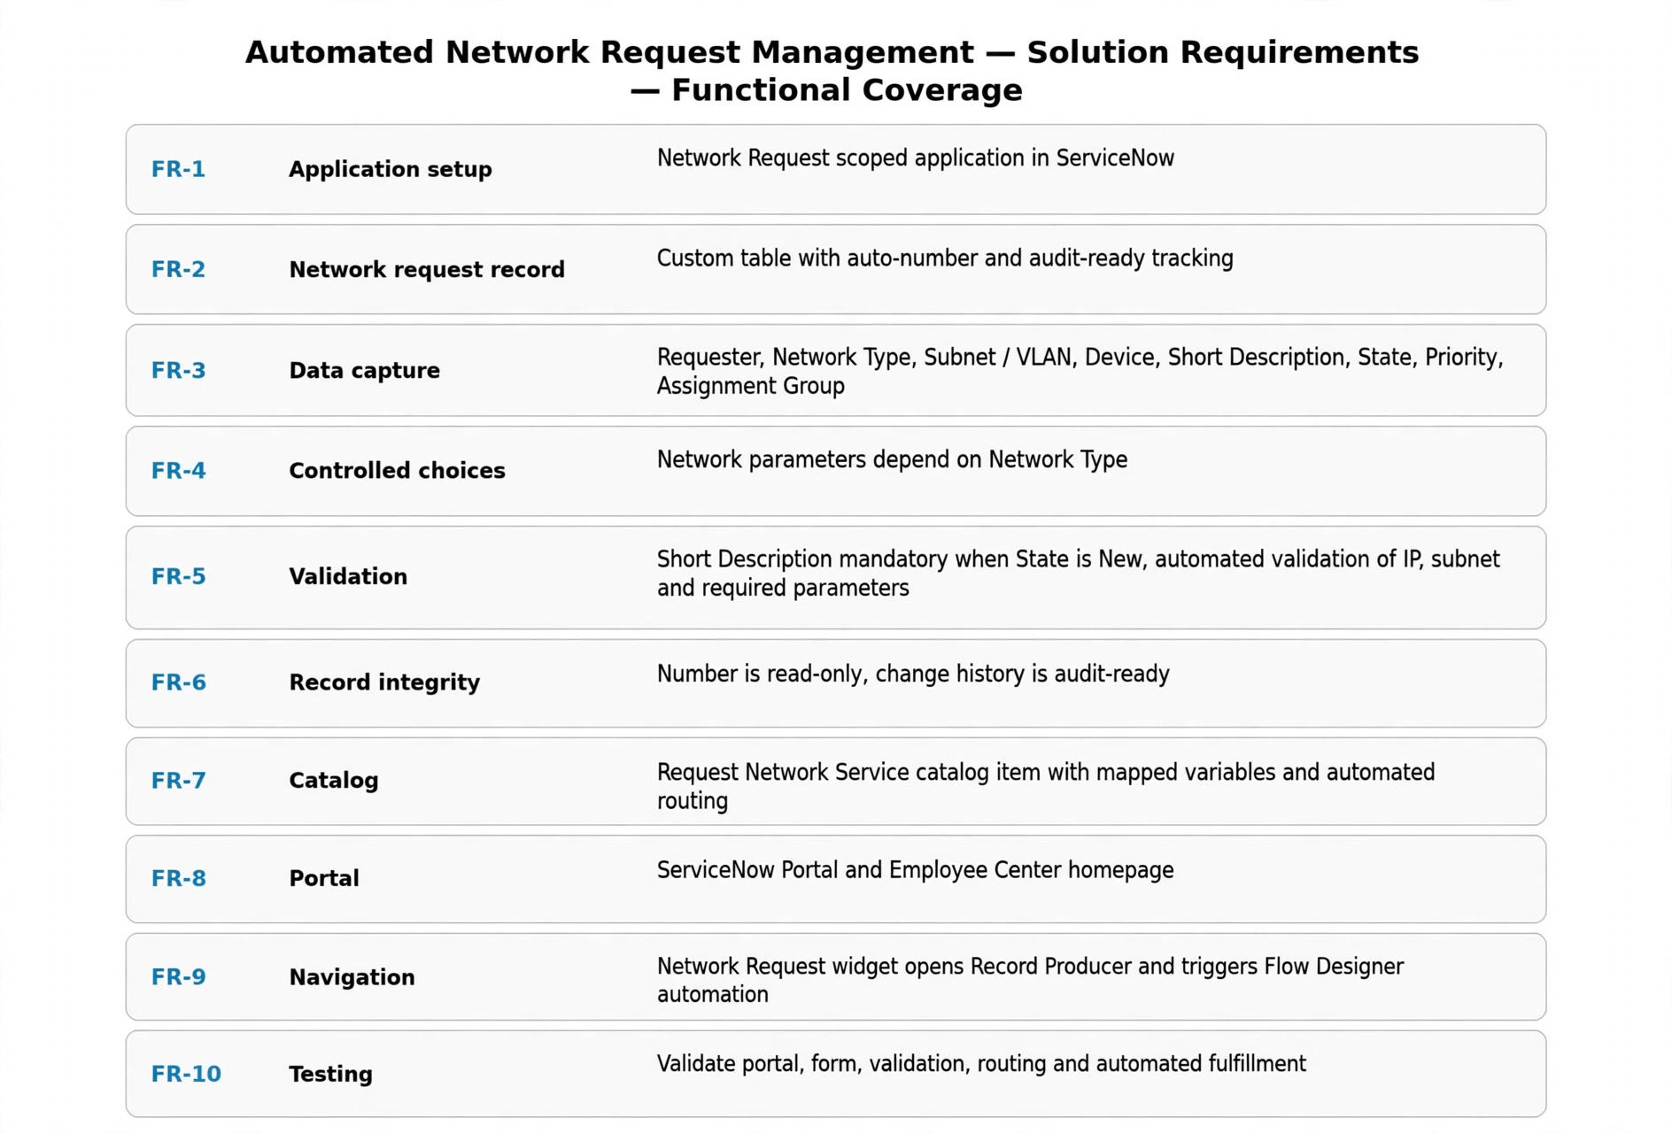
Figure 1: Functional requirement coverage.

